37.60: a) 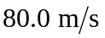is non-relativistic, and 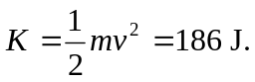
b) 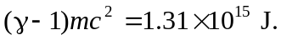
c) In Eq. (37.23),
d) 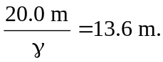
e) 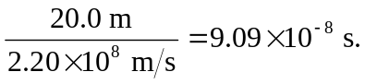
f) 